

Department of Computer Science, UET Lahore
Final Term Exam
Session | 2024 | Semester | Fall 2025
Course | Data Structures and Algorithms (Pr) | Registration No | 2024-CS-41
Time | 60 mins | Marks | 30

Question 1 [10 marks]
Implement Kruskal Algorithms. Input is given as a weighted graph and output should be a MST using Kruskal Algorithm.
Question No.2
Implement Insertion sort, such that your algorithms sort the elements on even indexes only and leave the odd indexes without any change. Pass start, end and array as parameter. [10 marks]
Question No.3 [10 marks]
Create an array A of 20 integers. We want to hash elements in A. Use the double hash technique for insertion of elements. Use the given formula to calculate the index of element to be added. Give user the ability to add element on CMD. On each insertion, print the array A.
$$h\left(x\right)=h_{1}\left(x\right)+i*h_{2}\left(x\right)$$
$$h_{1}\left(x\right)=x mod 7$$
$$h_{2}\left(x\right)=x mod 3$$
After adding 10 elements, write the array here which is being displayed on cmd.

Outputs:

Question 1:
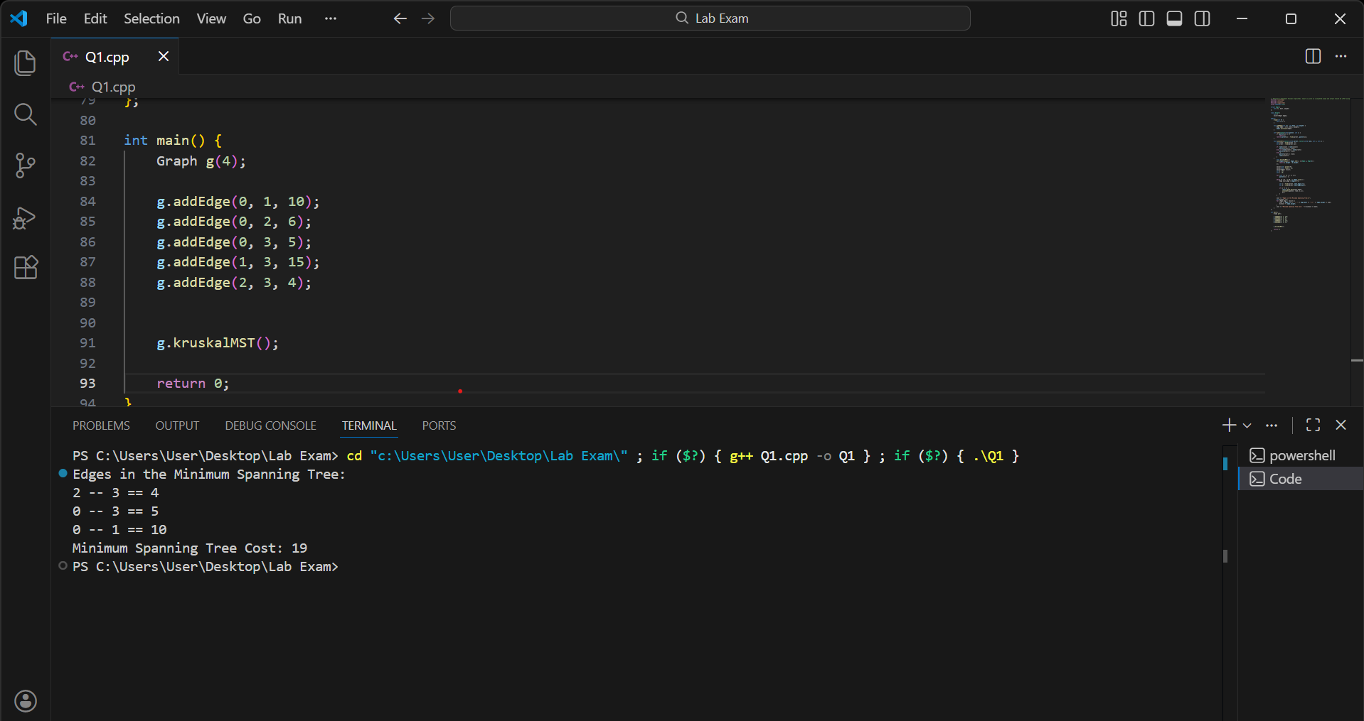
Question 2:
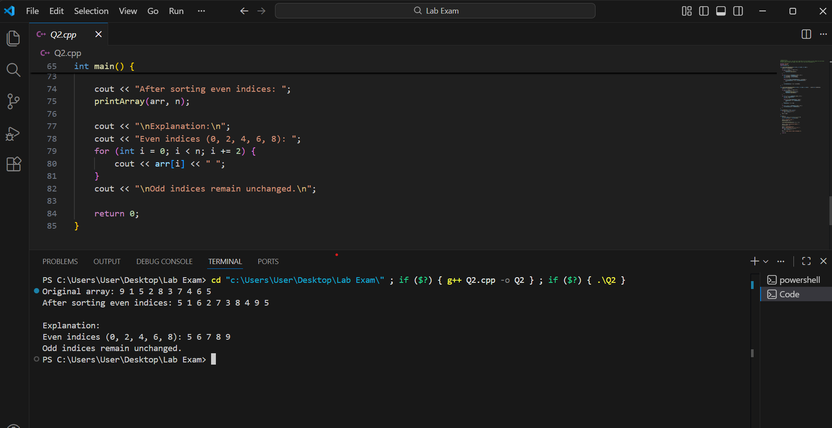

Question 3:
